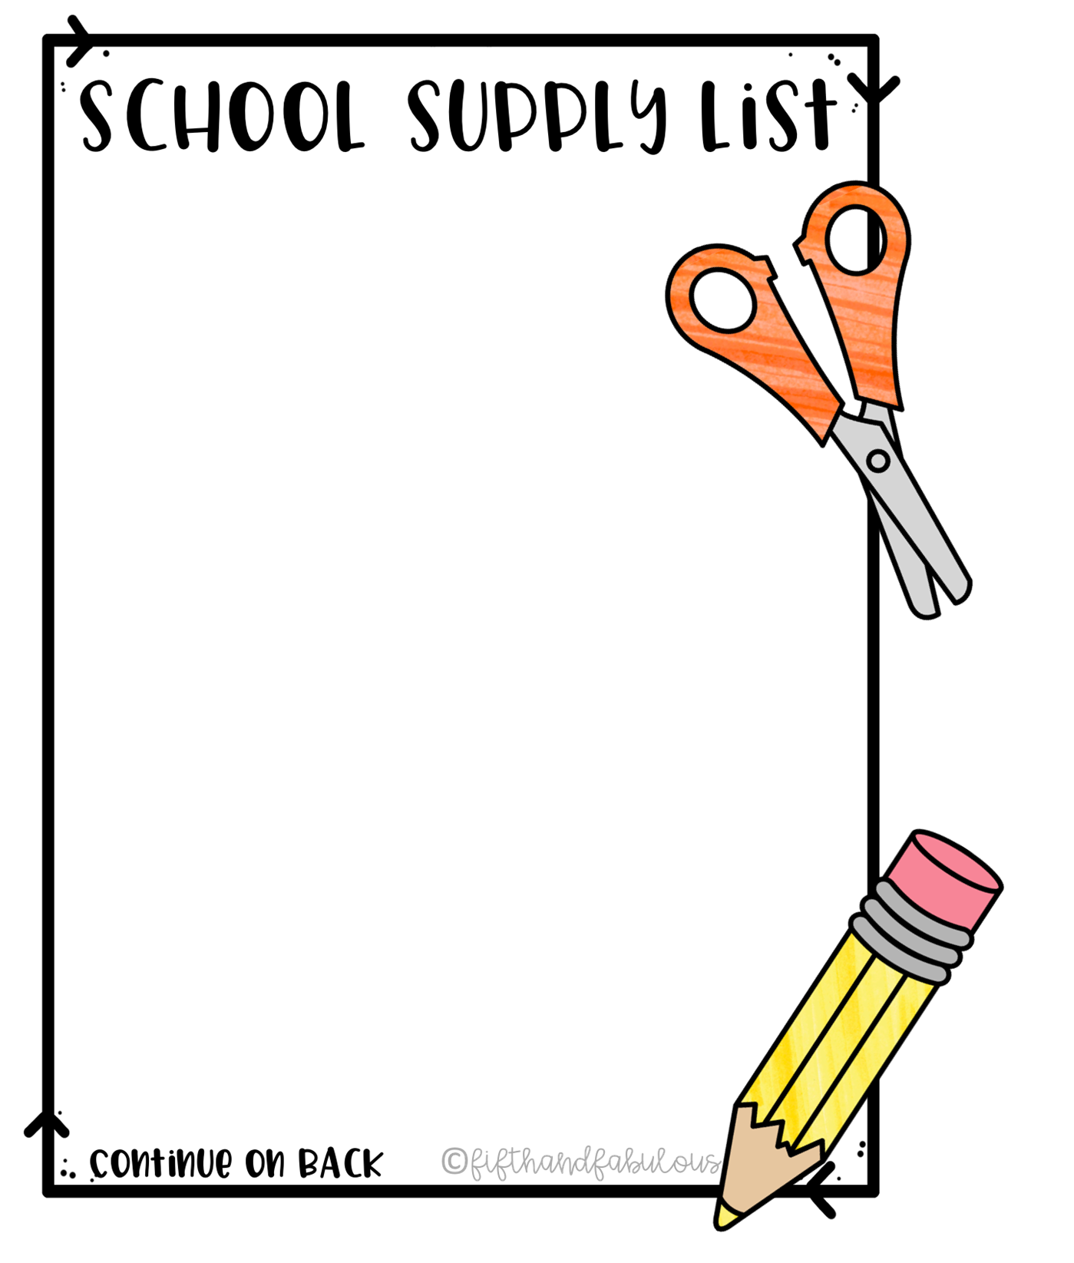

**K - 5th**

**Ms. Weston’s Class**

General Supplies

* 1 pack of #2 wooden pencils
* Box of Tissues
* Glue sticks
* Coloring pencil or Crayons (Please no Markers)
* Backpack
* 1 Primary Composition notebook with wide lines
* 1 Supply box
* 1 pack of index cards
* 2 Personal Headphones to keep at school with name on it.
* Change of clothes to keep at school with name on it

Appreciated Donations:

* Hand sanitizer
* Permanent Markers
* Copy Paper
* Dry Erase Markers
* Lysol wipes or spray